**Question 1- Easy**

**The Mystery Triangle Quest**

In a faraway magical land, three powerful wizards each wield a magical wand with a unique length. Together, they can form a mystical triangle if certain conditions are met. The type of triangle (by side) they form determines the type of magical barrier they can create, each with different properties.

You're given lengths of wands. Determine if the wands can form a magical triangle and, if so, identify the type of triangle based on the following rules:

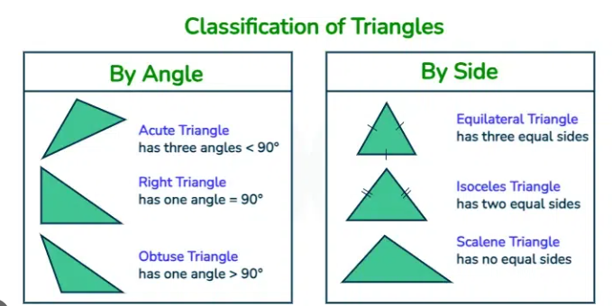

**1. Equilateral Barrier**: If the triangle is ‘Equilateral Triangle’. This barrier is strong against all types of spells.

**2. Isosceles Barrier:** If the triangle is ‘Isosceles Triangle’. This barrier reflects low-level spells.

**3. Scalene Barrier:** If the triangle is ‘Scalene Triangle’. This barrier weakens any single-target spell.

**4. Shattered Magic:** If the wands cannot form a triangle, they create a "shattered magic" that does not protect the wizards.

**Write a code that takes space separated three integers as inputs and print a string representing the type of magical barrier or "Shattered Magic" if the wands cannot form a triangle.**

**Input Format:**

Space separated three integers

**Constraints:**

**1<= length of a wand <= 200**

**Test Case 1:**

Input: 4 4 4

Output: Equilateral Barrier

**Test Case 2:**

Input: 5 5 8

Output: Isosceles Barrier

**Test Case 3:**

Input: 1 2 3

Output: Shattered Magic

*************************************************************************************

**Hidden Test Cases :**

Input: 3 4 5

Output: Scalene Barrier

Explanation: All wands are of different lengths, and they satisfy the triangle inequality, forming a Scalene Barrier.

Input: 8 4 4

Output: Shattered Magic

Input: 1 1 2

Output: Shattered Magic

Input: 10 10 15

Output: Isosceles Barrier

Explanation: Two sides are equal, and they satisfy the triangle inequality.

Input: 100 150 200

Output: Scalene Barrier

Explanation: All sides are different, and they satisfy the triangle inequality.

Input: 2 3 4

Output: Scalene Barrier

Explanation: All sides are different, and they satisfy the triangle inequality.

Input: 5 5 10

Output: Shattered Magic

Explanation: 5 + 5 is exactly 10, so it cannot form a triangle.

Input: 1 2 10

Output: Shattered Magic

Explanation: 1 + 2 is not greater than 10, so it cannot form a triangle.

Input: 7 10 12

Output: Scalene Barrier

Explanation: All sides are different, and they satisfy the triangle inequality.

Input: 100 100 99

Output: Isosceles Barrier

Explanation: Two sides are equal and the wands satisfy the triangle inequality, forming an Isosceles Barrier.

Input: 1 1 1

Output: Equilateral Barrier

Explanation: All sides are equal, forming an Equilateral Barrier.